 | 
North America Packaging  Guidelines for Suppliers |  |  |  |  |  | ZF LIFETEC PROCEDURE
REVISIONS
Date |  | Release No. | Description |  | Revision |  | Engineer
May 12, 2006 |  | ERD170420 | Initial release |  | A |  | Mark Rausch
Oct 1, 2013 |  | ERD332242 | Updated pallet specification and pallet sizes for International Suppliers |  | A01 |  | Leyanna DiGiovanni
January 25, 2016 |  | ERD 399955 | Updated pallet specification and pallet sizes for International Suppliers, update of maximum container weights and addition of new supplier packaging form |  | B |  | Leyanna DiGiovanni
March 20, 2020 | ERD 538858 | Updated pallet specification and pallet sizes for International suppliers, update Supplier Packaging Proposal form, unit load specification | C | Xavier Glenn
Sept 4, 2024 | ERD 538858 | Update Company Name to ZF LIFETEC | 01 | Olga Hernandez

PREPARED BY: |  |  |  | DISTRIBUTION:
Mark Rausch- Original Version
 |  |  |  | See ERD
CUSTOMER APPROVAL:
Not applicable
REQUESTED BY:
Senior Product Engineer - PKG



Active and Passive Safety TECHNOLOGY

North America

Packaging Guidelines for Suppliers

Table of Contents Page No.

1. Introduction 4
2. Purpose 4
3. Requirements 5
3.A General Requirements 5
3.B Packaging and Shipping Requirement 6
4. Supplier Packaging Proposal Form 7
5. Expendable Packaging …………………………………………………. 7
5.A Pallet Specifications ……………………………………………… 7
5.B Container Specifications …………………………………………. 9
5.C Dimensional and Load Limits ……………………………………. 9
5.D Palletizing …………………………………………………………… 9
6. Returnable Packaging……………………………………………… 10
6.A Returnable Container Systems………………………………. 10
6.B Returnable Load Heights…………………………………… 11
6.C Modular Returnable Containers… ……………………………. 11
6.D Removal of Exterior Identification from Returnable’s ………. 12
6.E Removal of Interior Dunnage ………………………………….. 12
6.F Returnable Washing / Cleaning ..……………………………...... 12
6.G Returnable Container Storage………………………………….. 12
6.H Load Stability ……………………………………………………. 12
7. Packaging of Prototypes and Pre-Production Parts ………………... 13
8. Palletizing …………………………………………………………………… 13
8.A Preparation for Shipment ………………………………………. 14
9. Definitions ……………………………………………………………... 14
Exhibit 1
Exhibit 2
Exhibit 3
Exhibit 4

1. Introduction

This document contains guidelines and specifications for the development, approval and use of packaging for product(s) being shipped to ZF Lifetec Active and Passive Safety Technology from suppliers and inter-company sources. The following guidelines will provide Suppliers with an overall awareness of the packaging and labeling requirements at ZF Lifetec and will guide them in developing a packaging concept and final package design that will meet the needs within the supply chain for safe, efficient and effective handling of the materials being transported from the Supplier to ZF Lifetec Active and Passive Safety Technology facilities.

It is the supplier’s responsibility to adequately package and to protect their product and assure defect-free products to ZF Automotive Active and Passive Safety facilities.

All parts shipped after March 1st, 2016 must be shipped in accordance with this standard.

2. Purpose

The purpose of these guidelines is to provide for the development, approval and implementation of a packaging strategy to be used in the transportation and handling process for product shipped from ZF Lifetec Active and Passive Safety Technology suppliers and inter-company sources worldwide. This guideline is designed to improve ZF Lifetec and trading partner productivity by providing effective and efficient development guidelines for packaging used for the purpose of product protection during transport, storage and point of use while optimizing efficient and safe product handling throughout the supply chain.

The standardization of supplier packaging is essential to the ZF Lifetec commitment to provide a cost-effective high-quality product to its automotive customers. The condition in which products arrive at our assembly facility is a critical extension of your company’s overall commitment to quality and performance. Therefore, it is essential that you adhere to the packaging and identification requirements defined in this manual.

Adherence to these specifications will reduce labor and transportation costs, enhance product integrity, improve data accuracy, and increase overall supply chain value. This guideline is intended to be used in conjunction with the ZF Lifetec North America Labeling Guideline DPF.C4.01.003.05

3. Requirements

3. A General Requirements

- Following are guidelines and specifications for the packaging of all materials to be supplied to ZF Lifetec North American operations from internal and external suppliers. Included are specifications for standardized pallets and containers, packaging approval process and guidelines for suppliers outside of North America.
- Compliance with these requirements is mandatory. Failure to comply with these requirements could result in a negative impact to the Suppliers performance ratings as well as a chargeback to the supplier regardless of freight agreement.
- The ZF Lifetec buyer SHALL be responsible to enforce these requirements on the supplier. Deviations from this guideline are subject to approval by the receiving plant packaging and manufacturing engineer as well as the senior corporate packaging engineer. Deviations must be formally submitted to the receiving plant packaging contact directly.
- Any questions or concerns regarding this specification should be directed to your ZF Lifetec plant packaging contact or purchasing representative.
- In this document the word SHALL indicates a requirement and the word SHOULD indicates a recommendation.
- Additional packaging requirements may also be specified on the individual part drawing documentation. It is the supplier’s responsibility to familiarize themselves with these requirements and assure that their packaging is following these guidelines.
- The packaging and shipping guidelines in this specification apply to all ZF Lifetec Active and Passive Safety Technology NA facilities.
All labeling shall be in compliance with ZF Liftec labeling specification DPF.C4.01.003.05

- Any deviation from this specification or packaging change, once a standard pack has been established, is subject to approval by the specific ZF Lifetec plant packaging and manufacturing engineer. All deviations must be formally approved in writing.
- It is the supplier’s responsibility to adequately package and to protect their product and assure defect-free products to ZF Liftec NA facilities. Regardless of freight agreement, supplier is responsible for the products integrity and quality from point of manufacture until point of fit at ZF Lifetec facilities. Package construction should be strong enough to withstand all rigors of all modes of transportation, handling and storage until the part is unpacked at ZF Lifetec NA facilities line side.
- The supplier shall work with the respective plant representative to ensure maximum space utilization within the package while optimizing the density of transportation in all conveyance modes.
- A packaging submission form must be submitted and approved by the plant packaging and manufacturing engineer and is a requirement of the PPAP Process.
- The supplier is responsible for the selection, design, construction of all packaging materials.

3. B Packing and Shipping Requirements

- Standardization and consistency are key in the development of packaging. Standard containers identified in this document are to be used. Once a standard is established and approved it is not to be changed without the written authorization of the receiving facilities packaging engineer.
- Only a single part number will be packaged into a given container at one time. A container is defined as the smallest possible shipping unit: i.e., carton, box, etc.
- Only a single lot number will be packaged into a given container at one time.
- Any reusable containers will be cleaned of all previous labels and miscellaneous debris prior to shipping to ZF Lifetec NA Facilities. Charge backs to the supplier are apparent if ZF Liftec should accrue any costs to clean containers of any debris from inside or outside of the containers.
- Except for applicable parcel shipments such as UPS, Fed-ex, etc, all incoming material will be palletized. Cartons / containers are never to overhang the pallet.
- Suppliers will meet all applicable state, federal, and international regulations regarding the packaging, marking, labeling and transportation of hazardous materials.
- All containers will be adequately sealed or covered to protect the contents during transit.
- Packaging slips (delivery note) shall clearly identify every shipment and will be placed at the top and center of the end of the load. The packaging slip will be protected from the elements in a clear plastic envelope. The packing slip at a minimum will contain a packing slip number (supplier assigned unique shipment identification number), applicable ZF Lifetec purchase order number(s), ZF Lifetec part number(s) and quantities per part. ZF Lifetec recommends the use of bar-coded packing slips (ref bar code labeling specification DPF.C4.01.003.05 )
- Containers will not be filled beyond the weight or height capacity of the container and will be readily stackable.
- Containers shall display shipping/parts identification labels on two adjacent sides of each container except in the case of returnable containers which provide label holders on opposite ends.
- Palletized loads shall display master labels. See label specifications DPF.C4.01.003.05
- Mixed part pallets will display mixed load labels. See label specifications DPF.C4.01.003.05
- The choice of packaging must take into consideration product characteristics, cost impacts, volume of production, delivery frequency, transport conditions and supplemental local ZF Lifetec Active and Passive Safety Technology NA requirements.
- All packaging must take into consideration the temperature and humidity extremes throughout North America. Humidity can range from 5% to 95% while temperatures can vary from – 30deg F to over 130 deg F.
- Containers designed to allow hand handling, including bundles, shall not exceed 30 lb or 13.6 kilograms maximum weight.
- Containers shall be modular to the pallet.
- Unique packaging dictated by a part (i.e., excessive oil, rust prevention, weight or fragility) not covered by these specifications are the responsibility of the part suppliers and must be qualified/approved by the receiving ZF Lifetec manufacturing location.
- Packaging materials must be readily disposable. Dunnage should be held to a minimum. Natural occurring materials such as kraft, fiber, corrugated and pulp dunnage are encouraged. The use of foam, bubble pack and peanuts are to be minimized.

4. Supplier Packaging Proposal Form

The supplier must submit a ZF Lifetec packaging proposal (Exhibit 1) for each production part intended to be supplied to a ZF Lifetec Active and Passive Safety Technology NA Plant.

- The proposal must be submitted to the ZF Lifetec NA receiving plant packaging contact prior to PPAP sign off.
- The supplier packaging proposal must be completed in its entirety with part and packaging details, dimensions, photographs, etc.
- The supplier packaging proposal is subject to approval by the receiving ZF Lifetec NA plant packaging contact.
- Trial shipments may be required by the receiving ZF Liftec receiving plant packaging contact prior to package approval.
- An approved and signed off packaging proposal form must be kept on file at the supplier’s location and is a requirement for the successful completion of the PPAP process.
- Preproduction shipments shall be made to ZF Lifetec facilities in production representative packaging.
- Any package testing deemed necessary by the supplier shall be carried out prior to shipment to ZF Lifetec NA facilities and shall be the responsibility of the supplier.
- Hazardous material package testing and recertification are the responsibility of the supplier.
- Contact your ZF Lifetec plant packaging contact with any questions regarding this process.

5. Expendable Packaging

5. A Pallet Specifications

- All shipments to ZF Lifetec Division R, NA Facilities. Pallets are to be notched to allow four-way entry (see Exhibit 2).
- Wing type pallets are to be used when the load is to be stretch wrapped.
- All lumber used in pallet construction is to be free of cracks or other defects that could result in failure in route to or at ZF Lifetec facilities.
- Pallets are to be of sound construction, capable of withstanding all rigors of all transportation modes and capable of supporting their load until emptied at its end destination ZF Lifetec facility.
- All wood used in packaging and the construction of pallets must meet the requirements of the International Standards for Phytosanitary Measures #15 as set forth by the Food and Agricultural Organization or the United Nations. See web site listed below http://www.ispm15.com/ISPM15_Revised_2009.pdf
- Packaging failure is often attributed to poorly constructed pallets. It is the supplier’s responsibility to purchase and use pallets suitable for their product. Part damage as the result of the use of unsuitable pallets will result in a charge back to the supplier.
5. A Pallet Specifications - Continued

- Returnable pallet bases (i.e., plastic) may be used in place of wooden pallets when shipping expendable cartons (for local suppliers only). This option MUST be approved by the plant packaging engineer prior to utilizing this method.
- Over pack carton can be used to contain and protect smaller cartons that are modular to the larger carton. The height of the overall pallet with cartons should not exceed 1270 mm (50 inches). Over pack cartons must efficiently maximize the surface area of pallet. Due to the conditions of ocean transportation over packs are strongly recommended. An over pack shall not overhang the perimeter of the pallet.
  - Inner cartons are to fit within the overpack to avoid wasted space.

- Corrugated used in over packs should be made of double or triple wall.
- Bulk containers should not be used unless material cannot be pack in handheld carton.
- Palletized loads will not exceed 1200 mm x 1140 mm x 1270 mm. (48x 45x 50).
- Gross weight of palletized loads will not exceed 800 kg. (1764#).
- Shipments originating outside of North America will most likely be moving by sea or air. As ocean container dimensions are different than over the road trailers, the pallet and container dimensions must maximize the available cube space available within the ocean container. Accordingly, following are the pallet requirements for suppliers outside of North America:

Following is a list of approved pallet sizes approved for the shipment of components to ZF Lifetec plants in North America. The pallet sizes are approximate outside dimensions.

Domestic NA Pallet Sizes
48’’ x 45’’ *Preferred
30’’x 32’’
International Pallet Sizes
800 x 760
760x 1140
760 x 760
1200 x 800

Note: These modular container sizes are the required outside dimensions to achieve a modular pallet. The containers used must be sized to fully utilize the length and width of the pallet but shall never overhang the pallet.
5.B Container Specifications
- Cartons may have a stitched or glued manufacturer’s joint.
- All cartons will display a box maker’s certificate (BMC).
- Various forms of interior dunnage may be required to protect the product. Such dunnage should be readily recyclable. (See 3B:18)
- Containers will be packed to eliminate any void within the container and to optimize package density.
- All containers must be capable of withstanding all modes of transportation and the environment it can be exposed to. Containers shall be capable of handling and supporting their load until emptied at its final destination ZF Lifetec facility.
- Containers must be adequately sealed to ensure failure does not occur during handling and storage.
- Closures shall be made by taping ONLY. Use of staples or gluing for closure is not permitted.
- The design of the container should allow for easy disassembly of the carton after the product has been removed.
- Cartons and containers to be individually handled shall not exceed 30 pounds (13.6 kilograms) individually.
- Components measuring 1x1x1’’ (25x25x25mm) LxWxH and smaller will be classified as “small parts”. All small components should be placed inside of a plastic bag prior to placing into the approved container.
- Carton sizes should be designed to maximize the surface area of pallet so as not to waste space. Carton configuration on pallets should be designed to achieve greater than 80% utilization of the pallet surface area.
- Under no circumstances will wooden crates, wooden boxes, or the like be used as a substitute for approved corrugate based packaging.

5.C Dimensional and Load Limits

- The maximum stack height of a single unit load of ALL domestic packaging shall be 50”. A 50” stack height optimizes trailer density. Loads stacked higher than this effect the trailer density negatively resulting in higher shipping and transportation costs for ZF Lifetec.

5.D Palletizing

1. Containers shall be within the perimeter of the pallet. That is, the container will never overhang the pallet.
2. Loads will need to be stretch wrapped and banded in all directions of the pallet. Metal banding is not permitted except for plant specific applications. Banding shall not interfere with the barcode readability.
3. All banded pallets shall have two bands in the length and two bands in the width.
(See Exhibit 3).
4. Stretch wrapped loads shall require a wing type pallet. (See Exhibit 2). Stretch wrap will secure the load to the pallet as well as binding the individual containers together as a load.
5. Edge or corner protectors will need to be used on unit loads when necessary to protect the container and the contents or were the unit load without such corner supports do not allow the unit load to be stacked in accordance to transportation requirements (utilized mostly for bulk containers but should be used when empty boxes are being added to prevent pyramid stacking). Protectors shall not extend beyond the palletized load.
6. When necessary, uniform packages containing different part numbers/lot numbers may be packed on a common pallet providing a Mixed Load label is used to identify it as such.
7. All containers shall be capable of withstanding the transportation environment and capable of handling and supporting their load to, and until emptied at, ZF Lifetec facilities. Containers shall arrive in satisfactory condition at the point of use.
8. Palletized loads shall have flush upper surfaces suitable for stacking. Pyramid stacking is not allowed. It is a requirement to utilize empty boxes to fill in the voids if the supplier part releases are not in even pallet layer quantities. Please first check with your ZF Lifetec plant packaging engineer to assure that the releases cannot be updated accordingly to ship even layers. (See Exhibit 4).
9. If releases do not result in full, flush pallet surfaces please bring this to the attention of the ZF Lifetec purchasing and material planners.

6. Returnable Packaging

The applicability of returnable containers is largely based upon geographic proximity of the supply base along with part, volume and cost considerations that drive the feasibility and use of returnable containers.

- The financial responsibility and management of the returnable container system and expendable backup packaging must be defined and agreed upon by the ZF Lifetec NA purchasing representative, plant packaging contact and the supplier prior to implementation and program launch.
- Returnable packaging pallet footprints are either 48” x 45” or 32” x 30”.
- Returnable containers shall be properly sealed and/or covered to protect the material during transit and storage.
- Returnable containers shall be properly palletized to protect material in transit. Returnable containers, pallet and top cap or lid are to be designed as a unit load to afford part protection and container optimization. Note: The pallet should have a positive interlock to containers that forms a secure load.
- Containers shall not overhang the pallet.
- Returnable container systems established between ZF Lifetec assembly plants and suppliers are used at the discretion of the assembly plant and will be administered by that facility.

6. A Returnable Container Systems

The returnable container system may include bulk containers, modular containers, and palletized loads.
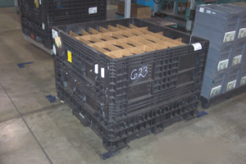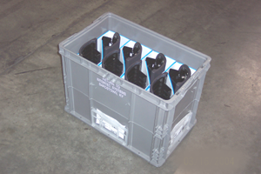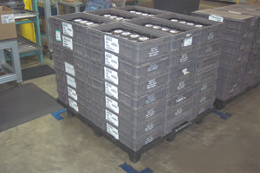
Bulk Containers Modular Containers Palletized Loads

6. B Returnable Load Heights

Recommended load heights, including pallet, shall be:
25” overall height (knockdown container)
34” overall height (knockdown container)
50” overall height (knockdown and modular containers)

Bulk container systems shall be sized to maximize cube-space in various modes of transportation to minimize freight costs. The returnable container shall be nestable, collapsible, or of the knockdown type in order to optimize the use of space while in storage and on return routes. The following are examples of acceptable cubing:

Length | x | Width | x | Height
48” | x | 45” | x | 25”
48” | x | 45” | x | 34”
48” | x | 45” | x | 50”
32” | x | 30” | x | 34”

Returnable bulk plastic containers unless otherwise specified, the container must be collapsible and be provided with two drop down gates to provide easy access to the interior of the container.

6. C Modular Returnable Containers

All containers shall be sized to fully utilize length and width of pallet or bulk container. Modular containers shall not overhang the length or width and shall not exceed the maximum overall height of 50”.
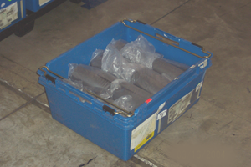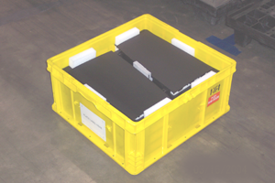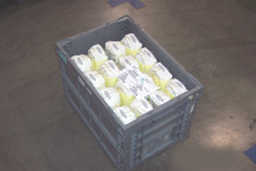

6. D Removal of Exterior Identification from Returnable’s

To avoid confusion or misidentification, the supplier shall remove all previous exterior barcode labels, shipping tags, etc before return shipment to ZF Lifetec. Chargeback’s to the supplier are evident if debris from the label is left on the container during shipments to ZF Lifetec.

6. E Removal of Interior Dunnage

ZF Lifetec NA will make every effort to remove interior dunnage / trash prior to collapsing / nesting of container. However, it is the responsibility of the supplier to ensure that containers are clean prior to use.

6. F Returnable Washing / Cleaning

Under certain conditions the supplier may find it necessary to wash / clean containers. The supplier shall provide containers free from dirt, oil, or other residue / debris which could jeopardize the quality of parts received at ZF Lifetec –NA.

6. G Returnable Container Storage

The supplier shall provide adequate storage to protect the containers from environmental elements to ensure container integrity. Containers are not to be stored outside.

6. H Load Stability

Palletized loads / bulk containers shall be adequately secured by stretch-wrap, banding, or seatbelt assemblies. When banding is used, non-metallic banding is mandated. Metal banding is strictly prohibited. Horizontal or “Belly” banding modular containers, in order to achieve load stability is prohibited. Under these circumstances it is recommended that there be an upgrade of materials used or additional corner posts should be used.

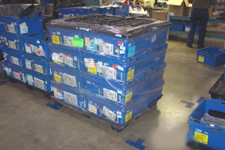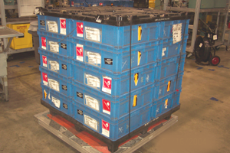

Shrink-wrapped skid Banded skid

Gross weight of a palletized load shall not exceed 2,000 pounds. When a palletized load dictates weight greater than 2,000 pounds, prior approval from the ZF Lifetec NA plant packaging contact shall be secured.

7. Packaging of Prototypes and Pre-Production Parts

Extra care must be given to the packaging and labeling of these parts. The package must totally encapsulate the product and provide protection from shock, vibration, impact and the elements.
In addition to the bar code labeling required in DPF.C4.01.003.05 , packages of prototype parts should be marked clearly to the attention of a specific individual at the receiving ZF Lifetec facility. Minimum information shall include: Part number (if available), Part description, Quantity, P.O. (if applicable), Supplier name, Deviation number, if applicable. Attention to: Program or project reference. The words “Prototype or Pre-Production” should be bold, black and 2” or 42mm high so not to be missed.

8. Palletizing

Banding will not be less than 12 mm in width. Banding shall not interfere with the barcode readability. Loads must be stretch wrapped and or banded to the pallet using plastic banding. Four bands, two in each direction should be applied. Two plastic bands can be used if the load is also stretch wrapped.

- Containers will be within the perimeter of the pallet. That is, the container will never overhang the pallet.
- Edge or corner protectors may be required to protect the container and the contents.
- Palletized packaging of like parts shall be physically capable of accommodating accumulated stack heights.
- All containers shall be capable of withstanding the transportation environment and capable of handling and supporting their load to, and until emptied at, ZF Lifetec facilities. Containers shall arrive in satisfactory condition at the point of use. Suppliers are responsible to facilitate packaging to ensure the goods arrive at ZF Lifetec destination in satisfactory condition.
- All unit loads shall be capable of being stacked more than 80’’ (2030mm) but no more than 100.5’’ (2553mm) in height during transport.
- All unit loads shall be strong enough to withstand being stacked 4 high in storage or to a height of 10.5’ (3200mm) whichever is greater.
- If releases or product requirements do not result in full, flush pallet surfaces please bring this to the attention of your receiving facilities materials group.
- When necessary, uniform packages containing different part numbers may be packed on a common pallet provided a mixed load label is used.
- Palletized loads shall have flush upper surfaces suitable for stacking. Pyramid stacking is not allowed.

8.A Preparation for Shipment

Ocean transport is subject to a harsher environment than over the road transportation the ship and its cargo can be subject to forces not typically experienced in over the road transportation. Suppliers outside of North America will need to consider this in their package design. Following are some of those factors and some suggestions:

1. Rust or corrosion
Ocean transportation can subject its freight to a very corrosive environment. Metal components may require a sealed poly bag and the inclusion of a volatile corrosive inhibitor (VCI).
2. Moisture, humidity
Ocean freight can be exposed to extremely high levels of humidity. A moisture barrier waxed or otherwise coated corrugate over the exterior of the container can prevent excessive moisture from weakening the corrugated. Wood corner supports can be added to provide extra support. A desiccant may need to be included within the package.
3. Blocking and bracing
Full shipping containers loaded by supplier shall be properly blocked and braced to withstand the rigors of ocean shipment. ZF Lifetec expects that its global suppliers be cognizant of the forces of ocean transportation and package and prepare their shipments accordingly such that their product will be received at our facilities in perfect condition.
4. Labeling
- Each container requires two bar code labels to be located on an adjacent side. A container is defined as the smallest possible shipping unit: i.e., a carton, box, etc.
- Barcode labeling specifications can be found in ZF Lifetec procedure DPF.C4.01.003.05 . Please ask your packaging engineer to provide a copy to assure compliance.

9. Definitions

Bulk container: A moderate to large container in which large quantities of a commodity can be transported. (i.e., knockdown container)

Collapsible container: A container which when empty, may be collapsed (broken down) or folded without disassembling its components parts.

Container Identification: The means by which containers are identified or coded either visually, numerically, or alpha numerically.

Container System: The aggregate of components which containers and protects parts during handling, transportation, and storage. (i.e., totes, pallets, caps, dunnage, etc.).

Gross Weight: The total weight of the container and its components.

Knockdown Container (KD): A container which, when empty, can be broken down by disassembling its component parts.

Modular container: A subset of a footprint. In a palletized load, those smaller containers which, when fitted together, form a unit load (i.e., tote).

Nestable Container: A container which fits compactly within a second container of the same type.

Package: The smallest shippable unit, a box, tote or container on a pallet.

Returnable Container: A reusable container, which by design and function, permit it to be used repeatedly for a substantial period of time.

Unit Load: The composite of pallet, totes, dunnage, top enclosure, and components making a single skid load.

Tare Weight: The weight of the container and dunnage only.

Stackable Container: A container or container system having features which allow each container to support another independent of the contents therein.

Double click on
Packaging Proposal
ICON

Exhibit 1: Supplier Package Proposal form. Double click the form ICON to activate. Complete all sections and save this form as the ZF Lifetec part number .xls (*******.xls) and return to your ZF Lifetec packaging contact. You MUST obtain approval of the packaging form prior to first shipment.

Four-way Entry Wing Style Pallets
48” x 45” Pallet
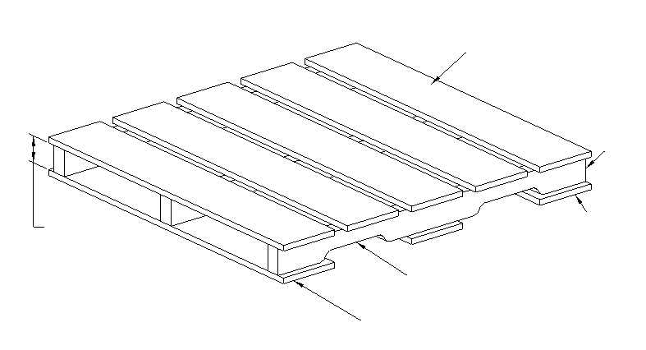
Opening Height ID
Height 3 ½”
Top Deck Board
Notched
Runner
Lower Deck Board
Openings Require 2” Height
Clearance and Should Be
9” Long and 24” On Center
Upper and Lower Deck Boards Must Overhang Pallet by 1” Minimum

Exhibit 2

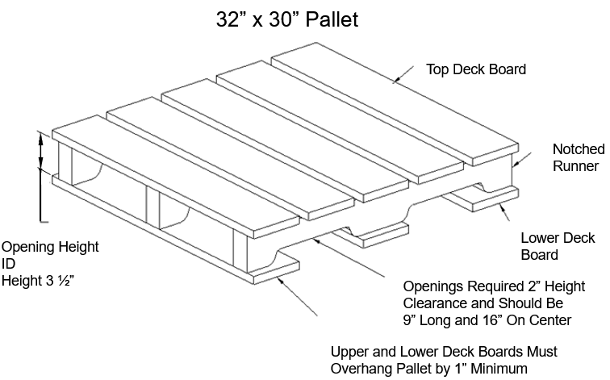

Pallet must be capable of supporting its load until emptied at our facility.

Palletized Load, Strapped for Shipment

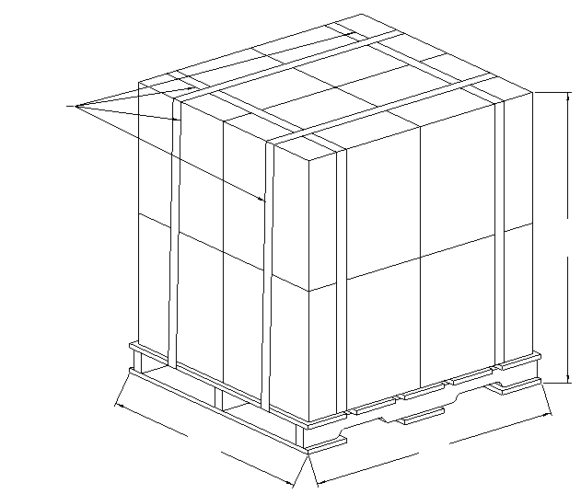
Strapping
45”
48”
50”
Exhibit 3

Maximum palletized dimensions are 48” x 45” x 50”

Examples of Properly Palletized Loads

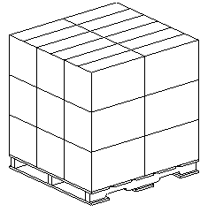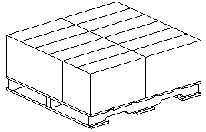

(ACCEPTABLE) (ACCEPTABLE)
Exhibit 4

Examples of Pyramided Unit Load

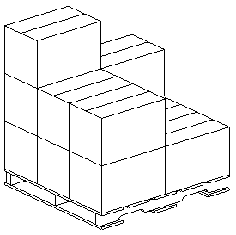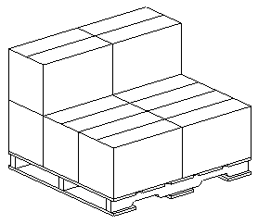

(NOT ACCEPTABLE) (NOT ACCEPTABLE)

